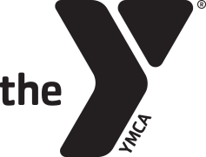

**The Y Diabetes Wellness Program – Referral Form**

The Middlesex YMCA provides a free 12 week exercise and wellness program to diabetic and

pre-diabetic patients. Eligible recipients must be referred by a registered health care provider and must live in Middlesex County.

**Patient’s Information**

Name: ______________________________________ Address ______________________

Date of Birth: __________________ Telephone Number: __________________________

**Healthcare Provider’s Information**

Healthcare Provider’s name: __________________________________________________

Telephone Number: ______________ Email: _____________________________________

Healthcare Providers Signature ________________________________________________

**Reason for referral**

* ____ pre diabetic
* ____ diabetic

**Wellness Goals**

**Information or Special Considerations for Y Staff to Best Support Your Wellness Goals**

Middlesex YMCA 99 Union Street, Middletown, CT 06457 P 860.347.6907 F 860.343.6254 www.midymca.org